1. This projects purpose was very simple, and it was to let me be lazier when I get a burst of energy in the middle of the night. It completes this purpose by being a box I don’t have to open and don’t need to turn on lights in my home to see it’s contents. To do this it has a motor, LEDs, and a motion sensor connected to the atmega168. When motion is detected the motor activates opening the box while the LEDs turn on to illuminate the box.

|  |  |  |
| --- | --- | --- |
| Name | Model Number | Description |
| DC motor |  | Makes the lid open |
| Motion Sensor | 4331029690 | Detects when the box need to change |
| Red/Green LEDs |  | Illuminates the box |
| Box |  | Is a box |
| Make Shift Hinge |  | Helps the motor open the box |
| Atmega 168 |  | Gives the commands to the components |
| Breadboard |  | Connects all the components and power |
| Wall plug in |  | Powers the system |
| L293D |  | Connects the motor to the Atmega |

1. 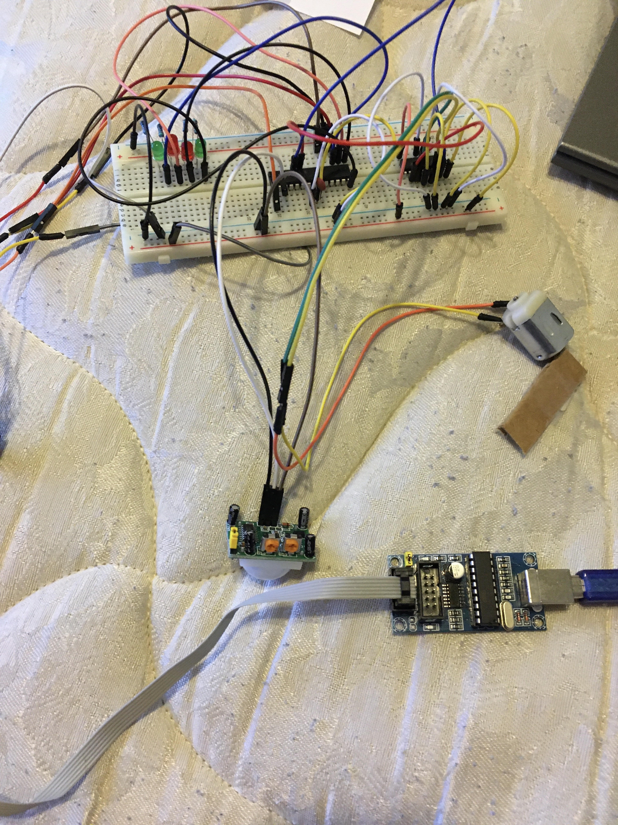

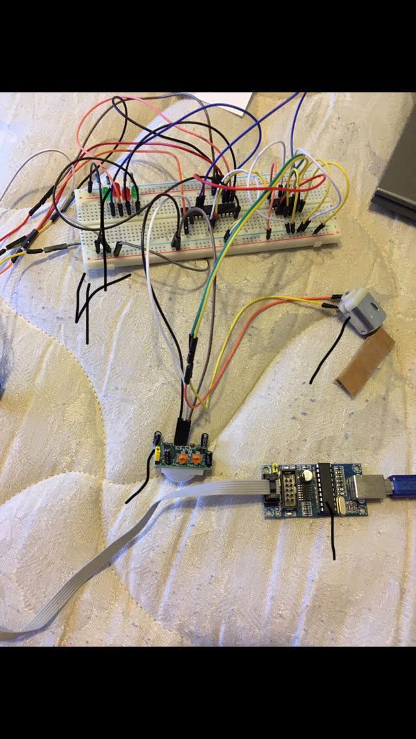

LEDs

DC motor

Motion Sensor

Programmer/Power



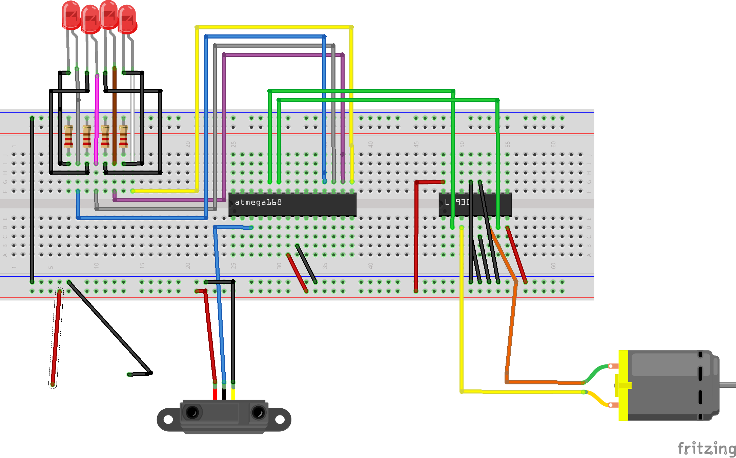

1. The Atmega168’s main role in the device is to trigger the interrupt when motion is detected, but it also turns on and off the LEDs and starts and stops the motor in a set direction for a set ime.

1. Users Manual
   * To use this product the user must plug the blocks plug into the wall and wave their hand on the size of the box.
   * With the circuit set up and the firmware flashed onto the Atmega plug the USB port of the programmer into a charging cube (as in the type that come with phones) and your good to go.
2. My firmware code is set up as a state machine with a defined type to handle the different states of the device. My created methods include a method for enabling the interrupt control, the interrupt method that changes the state the device is in when input is received, and the main method. The main method after setting the appropriate values and declare the correct methods it goes into a switch case based on what the previous state was, and from there it will either make the motor go clockwise or counter clockwise and sets the LEDs from on to off.
3. N/A
4. My biggest limitation was time as the firmware works and the design was ok but the motor I used wasn’t strong enough to open the box, and the battery connector I planned on using didn’t work the as I wanted it to.
5. https://youtu.be/EIgn4i-plVM